Operating mode

Consolidate network

A QGIS toolset to consolidate network data

Contents

Installation 3

Use 5

# Installation

**Prerequisites**

To make the plugin work, you must first have installed QGIS in its extended version (with OSGeo4W and minimum QGIS 3.16).

Save the following zipfile to your computer :



Next, you will have to import the zipfile containing the plugin in this way :

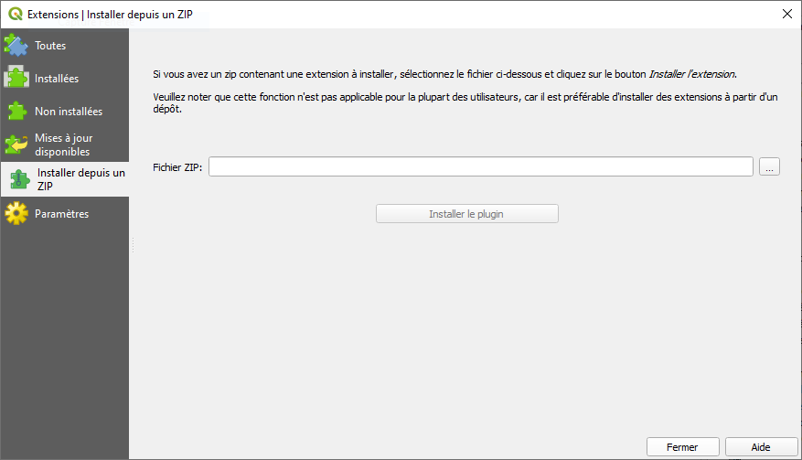

**Presentation of the plugin**

Once the plugin is installed, you can access the algorithms by opening the processing panel.

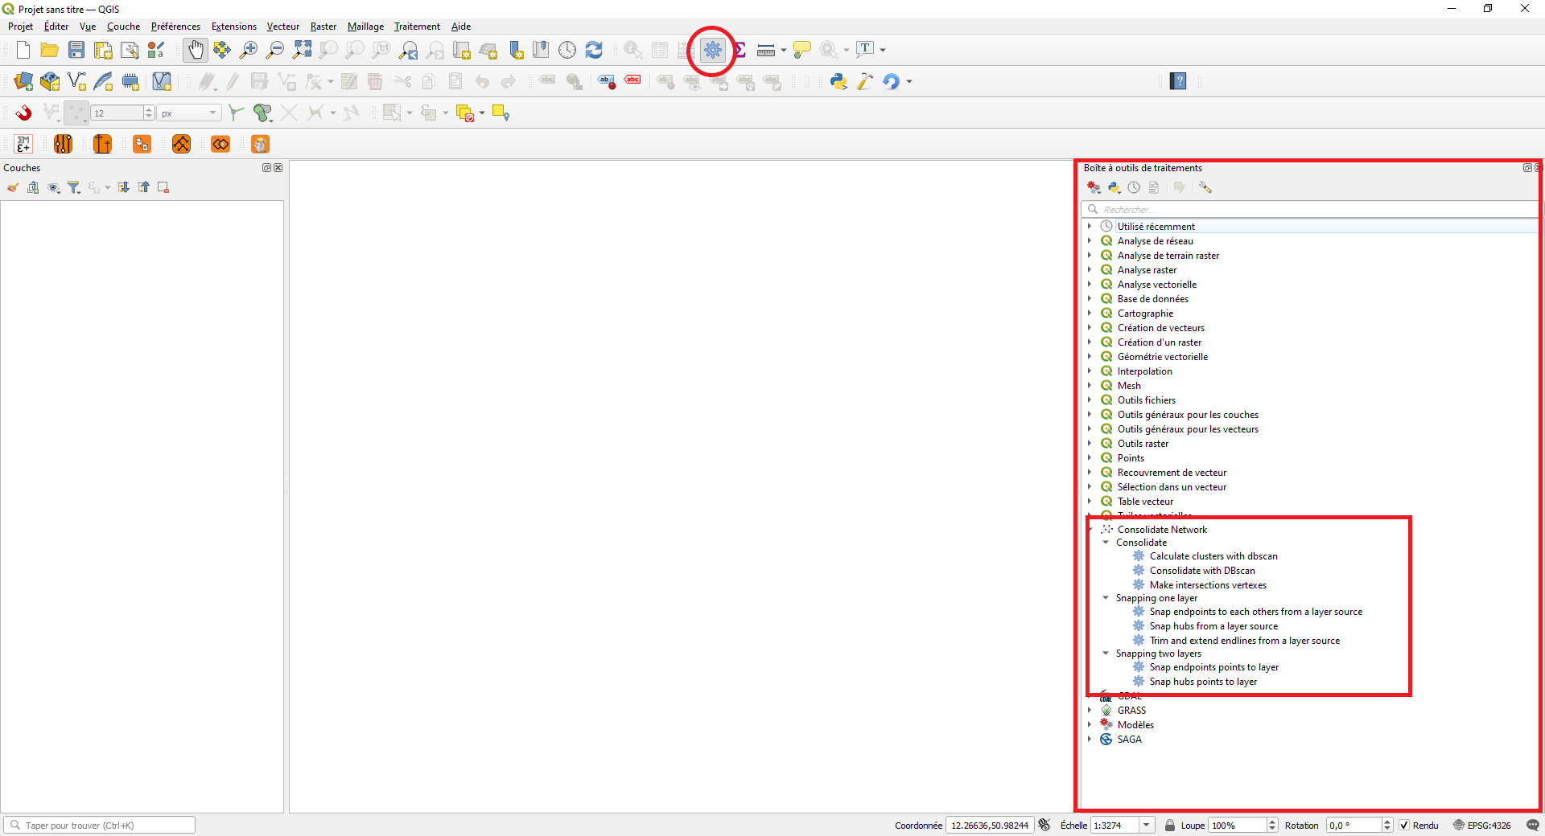

Algorithms can be used separately or they can be combined in a QGIS model, like this one :



# Use

**Main pipeline**

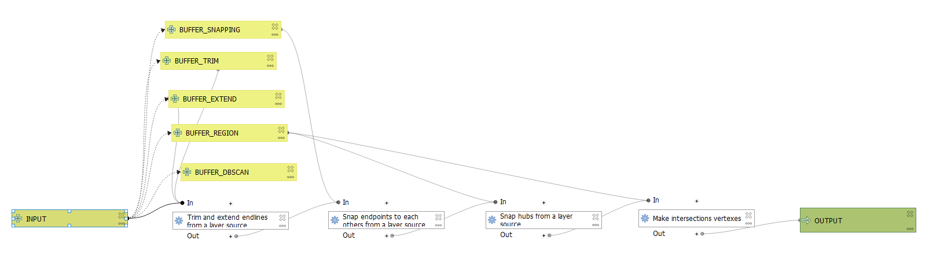

This pipeline is made up of four algorithms.

We start by shortening and extending the import lines.

Secondly, two snapping algorithms will help us consolidate the import network.

The first allows to snap the end points to the vertices of the nearest entities.

The second searches for the intersections of more than 2 entities, calculates the centroid of the polygon created by the vertices of the intersected entities and snap them to the centroid.

Finally the last algorithm creates the vertices on each point in common between the different entities in order to obtain a well connected network.

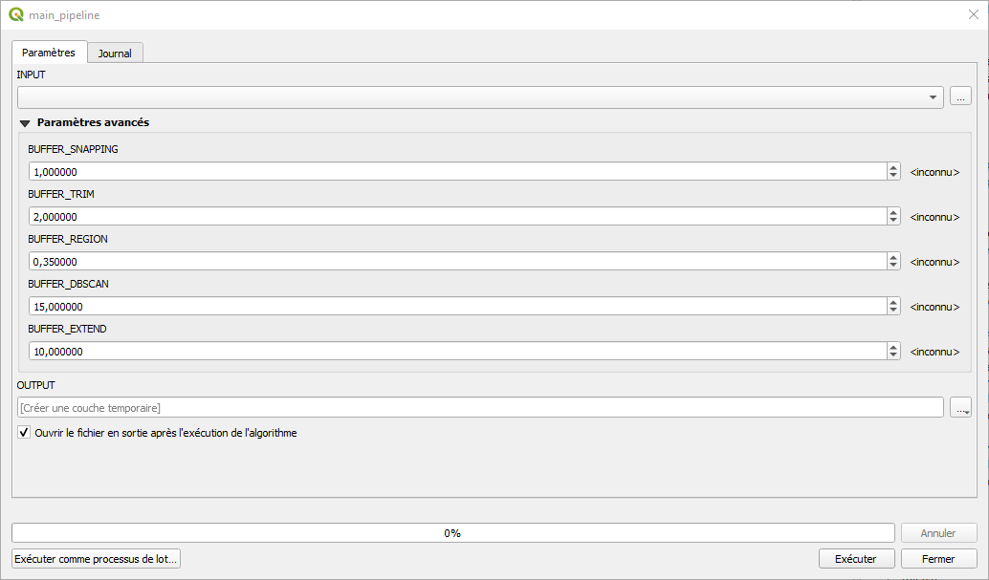

INPUT : the input layer.

BUFFER_SNAPPING : buffer for snapping endpoints to the closest vertex.

BUFFER_TRIM : buffer for trimming lines.

BUFFER_EXTEND : buffer for extending lines.

BUFFER_REGION : buffer for find the intersections areas of interest.

BUFFER_DBSCAN : buffer for snapping groups of well connected lines.

Depending on the input data, you will need to adjust these variables.

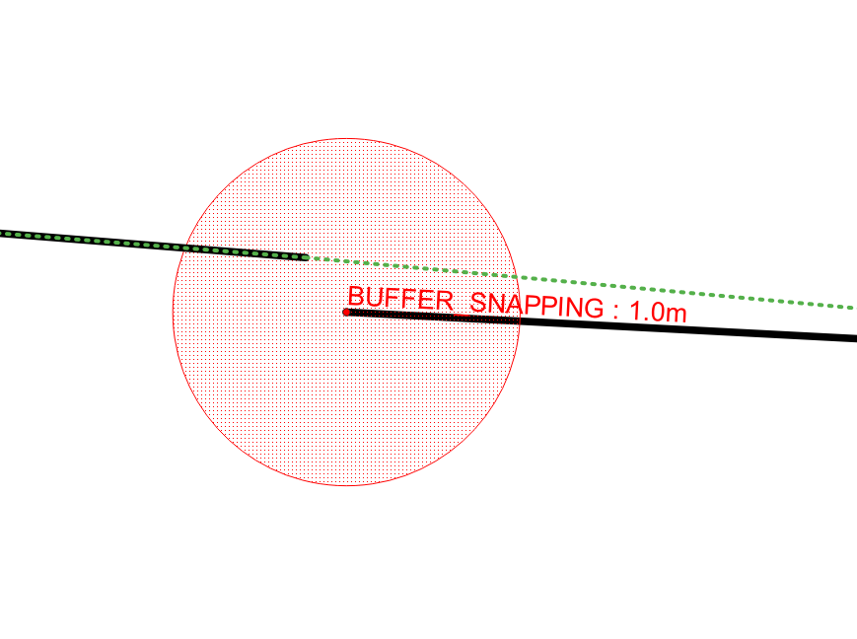

Snap endpoints to each others from a layer source

Trim and extend endlines from a layer source

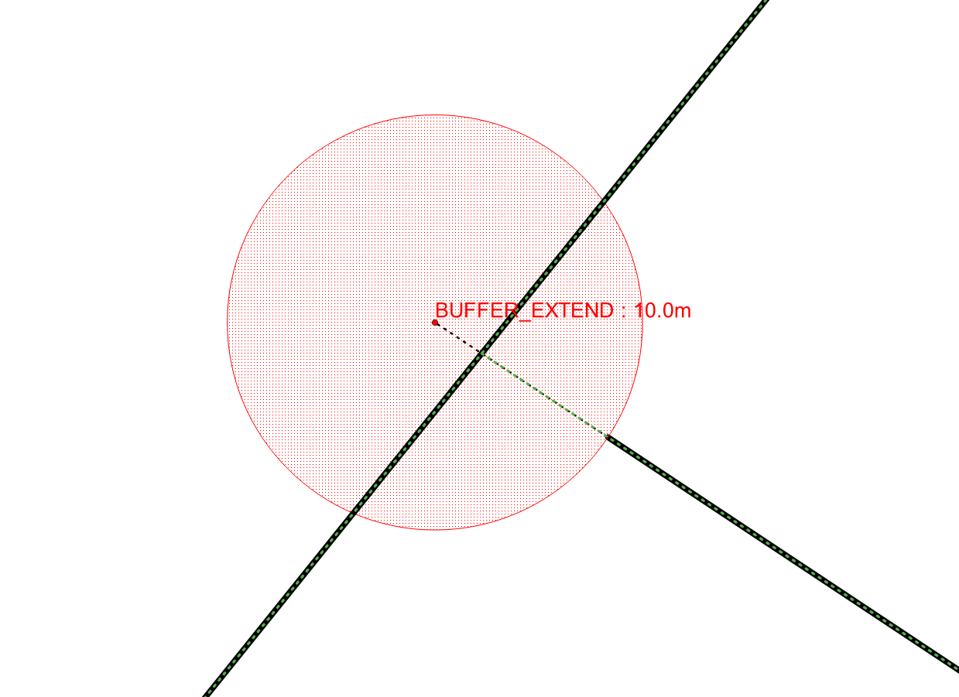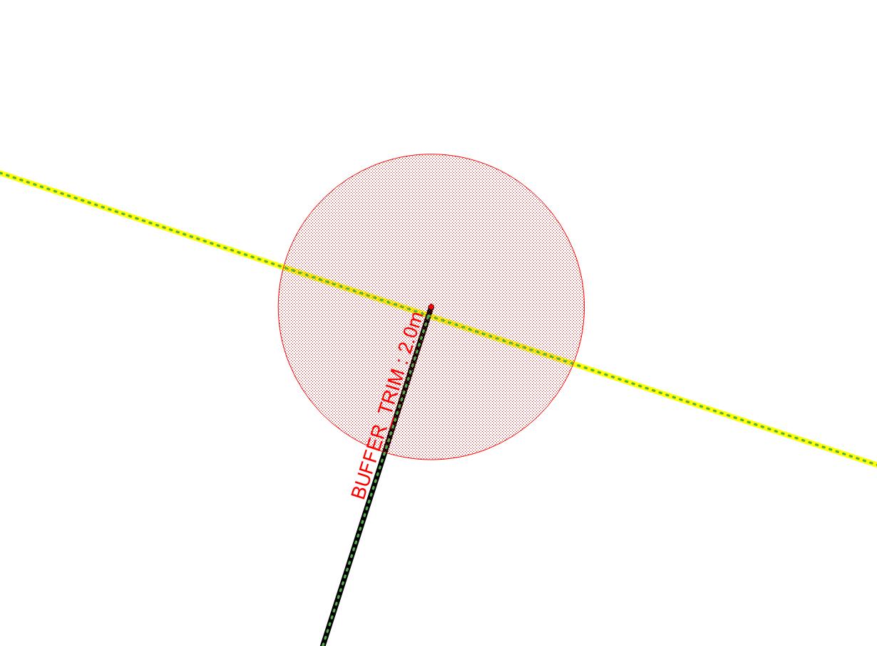

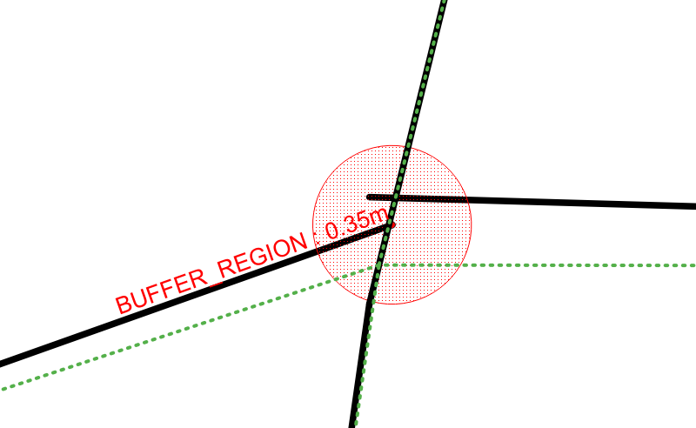

Snap hubs from a layer source

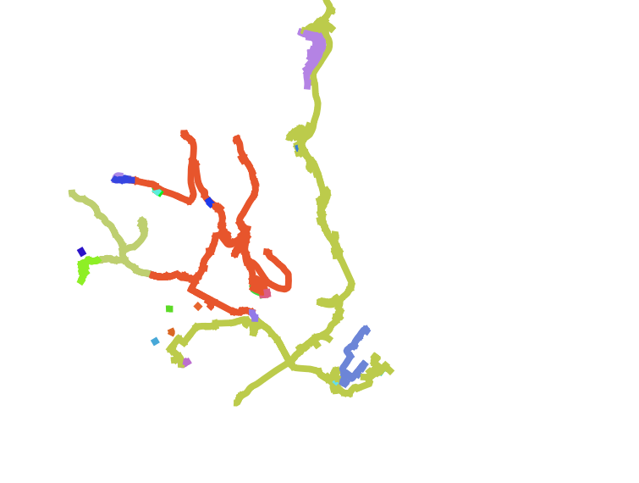

Calculate clusters with dbscan

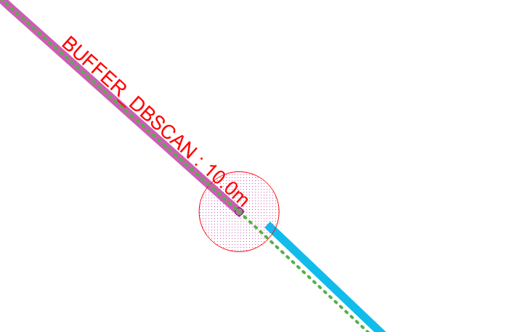

Consolidate with DBscan

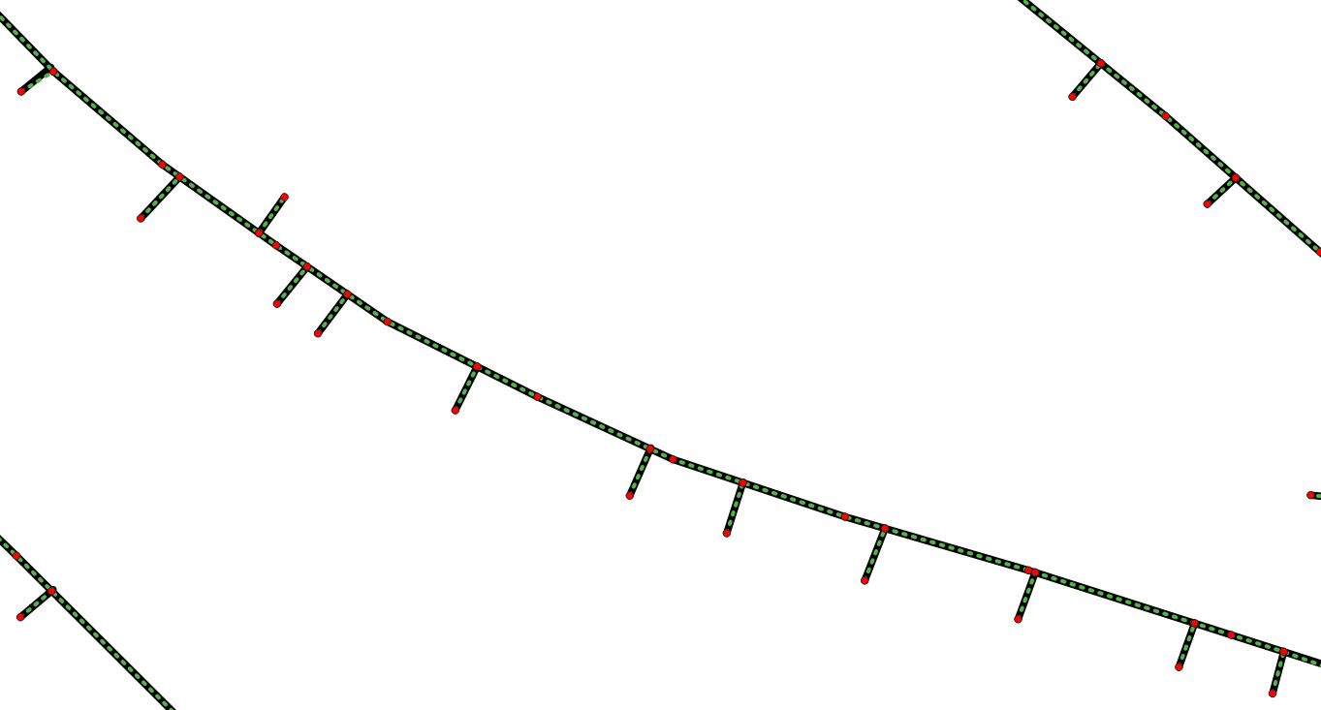

Make intersections vertexes